## **Objectives**

* Explain various ways of conditional rendering
* Explain how to render multiple components
* Define list component
* Explain about keys in React applications
* Explain how to extract components with keys
* Explain React Map, map() function

In this hands-on lab, you will learn how to:

* Implement conditional rendering in React applications

## **Prerequisites**

The following is required to complete this hands-on lab:

* Node.js
* NPM
* Visual Studio Code

## **Notes**

Estimated time to complete this lab: **60 minutes.**

Create a React App named “bloggerapp” in with 3 components.

1. Book Details
2. Blog Details
3. Course Details

Implement this with as many ways possible of Conditional Rendering.

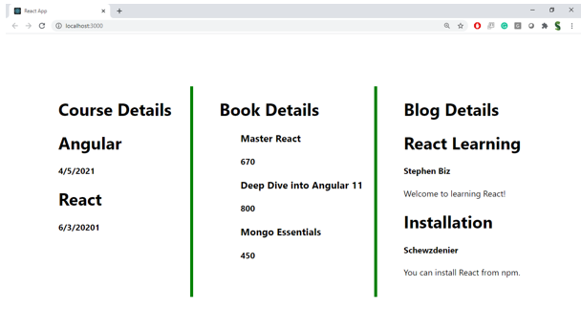

**Hint:**

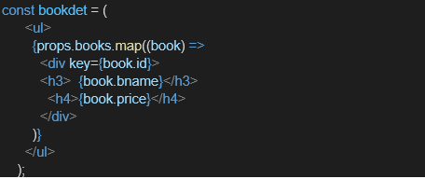

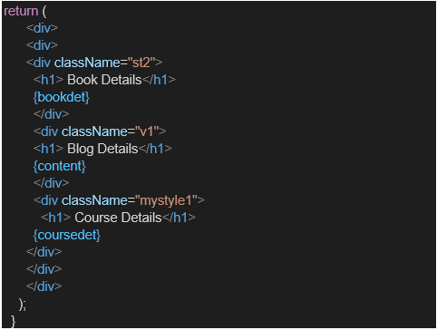

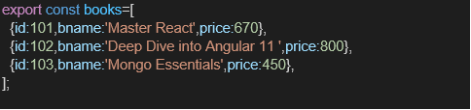

**SOURCE CODE**

**File: App.js**

import React from 'react';

function App() {

const books = [

{ id: 1, bname: 'Master React', price: 670 },

{ id: 2, bname: 'Angular 11 Deep Dive', price: 800 },

{ id: 3, bname: 'Mongo Essentials', price: 450 }

];

const blogs = [

{ id: 1, title: 'React vs Angular', author: 'John' },

{ id: 2, title: 'State Management in React', author: 'Jane' }

];

const courses = [

{ id: 1, cname: 'Full Stack Web Dev', duration: '3 months' },

{ id: 2, cname: 'DevOps Bootcamp', duration: '2 months' }

];

// 1. Conditional rendering using element variable

let bookContent;

if (books.length > 0) {

bookContent = (

<div>

<h2>Book Details</h2>

{books.map(book => (

<div key={book.id}>

<p><b>{book.bname}</b></p>

<p>Price: ₹{book.price}</p>

</div>

))}

</div>

);

}

return (

<div style={{ padding: '20px' }}>

<h1 style={{ textAlign: 'center' }}>📚 Blogger App</h1>

<div style={{

display: 'flex',

justifyContent: 'space-between',

border: '2px solid green',

padding: '20px'

}}>

{/* Book - element variable */}

<div style={{ width: '30%', borderRight: '2px solid green', padding: '10px' }}>

{bookContent}

</div>

{/* Blog - ternary operator */}

<div style={{ width: '30%', borderRight: '2px solid green', padding: '10px' }}>

<h2>Blog Details</h2>

{blogs.length > 0 ? (

blogs.map(blog => (

<div key={blog.id}>

<p><b>{blog.title}</b></p>

<p>Author: {blog.author}</p>

</div>

))

) : (

<p>No blogs available</p>

)}

</div>

{/* Course - logical && */}

<div style={{ width: '30%', padding: '10px' }}>

<h2>Course Details</h2>

{courses.length && courses.map(course => (

<div key={course.id}>

<p><b>{course.cname}</b></p>

<p>Duration: {course.duration}</p>

</div>

))}

</div>

</div>

</div>

);

}

export default App;

**OUTPUT:**

